**AWS Lab Access**

To login to the AWS account, please browse to the below URL:

<https://bit.ly/2nhKGAQ>

Signup with your **email account** and you will be redirected to AWS Console as shown below

Make sure that you are in **N.Virginia** region

If you have been redirected to **Ohio** region, please update the region to N.Virginia from the dropdown from the top right as shown below.

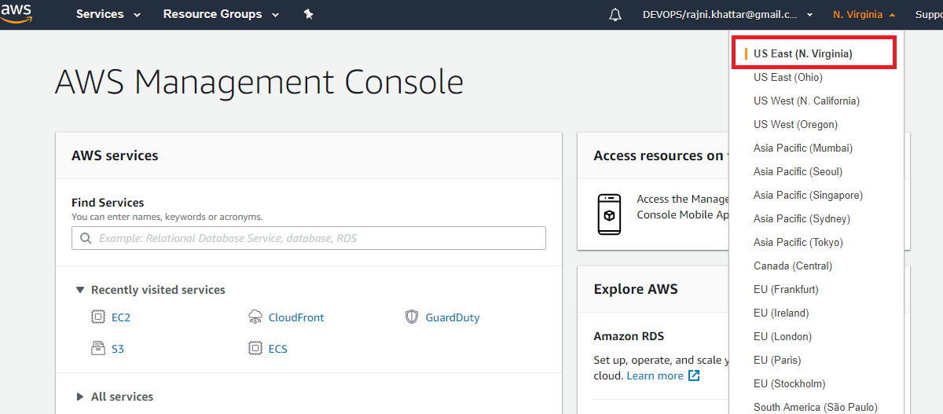

Now navigate to Services -> Click on **EC2** ( Elastic Compute Cloud).

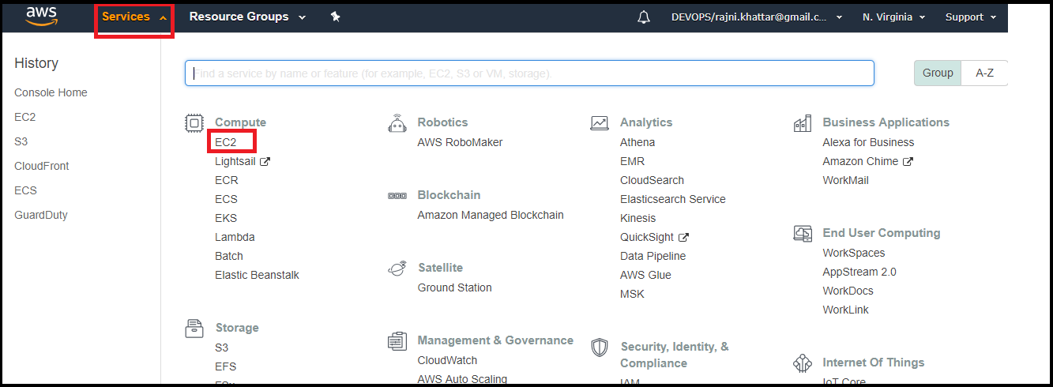

Follow the steps mentioned below:-

1. On the **EC2 Dashboard,** click on **Launch Instance** as shown below:  
   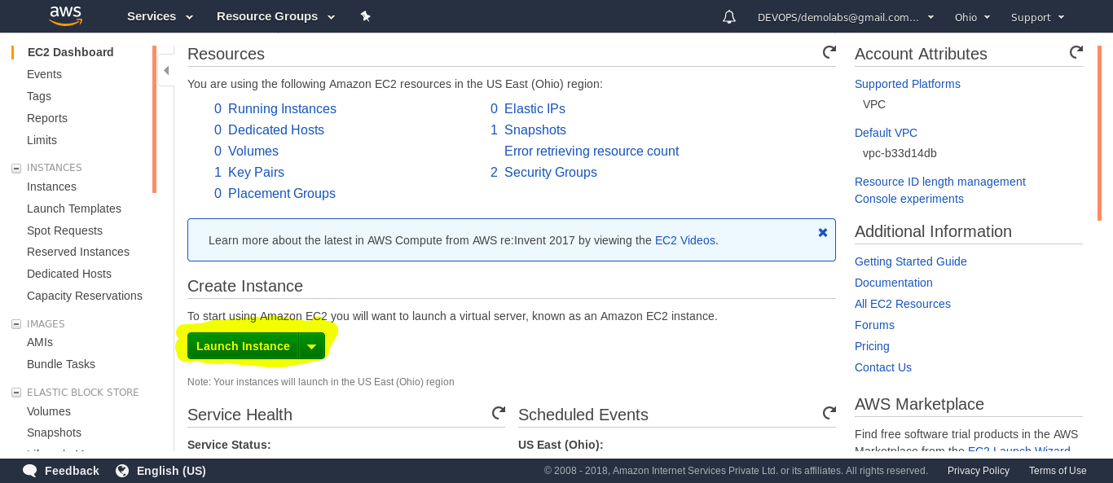

2.) Select **DevOps available under My AMIs**

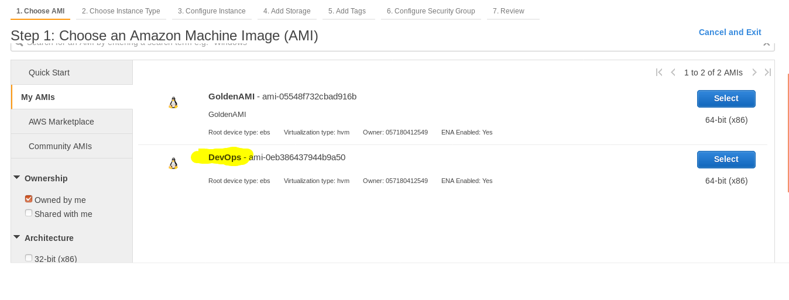

**3.)** Now on **Choose Instance Type** tab, Scroll down and select the **General purpose** **t3.medium** as the **Instance Type** and Click on **Next: Configure Instance Details**

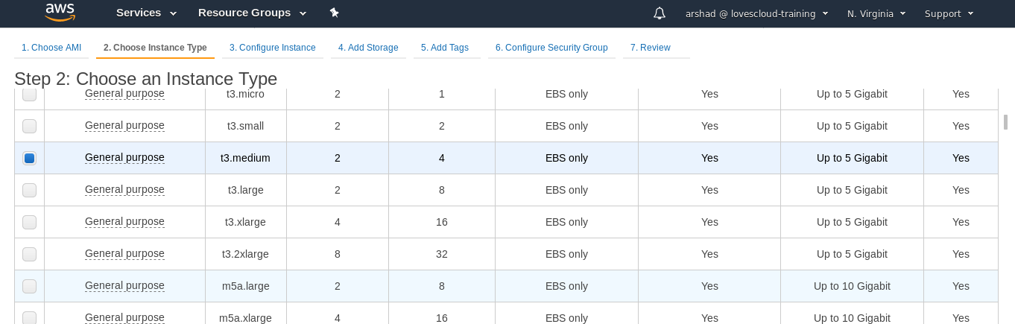

4.) On **Configure Instance** Tab**,** Click on **Next: Add Storage**  button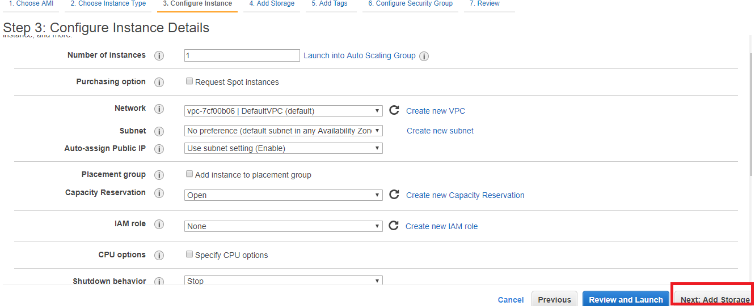

5.) On  **Add Storage** Tab, Ensure the **Size(GiB)** of the instance is **30GiB**, Click **Next:Add Tag**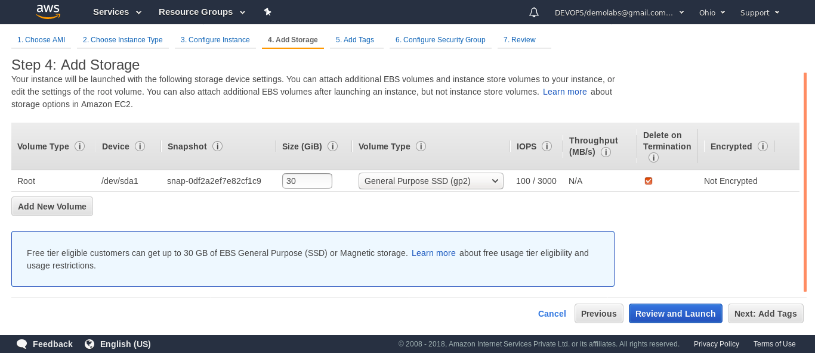

**6.)** On  **Add Tags** Tab, Click on the Add **Tag**  button.

Under Key, type **Name** and in  **Value** , type a tag name in the format **<your-name>** and replace <your-name> with your name so that you can identify your instance once it has been launched and then click on **Next: Configure Security Group**  button.

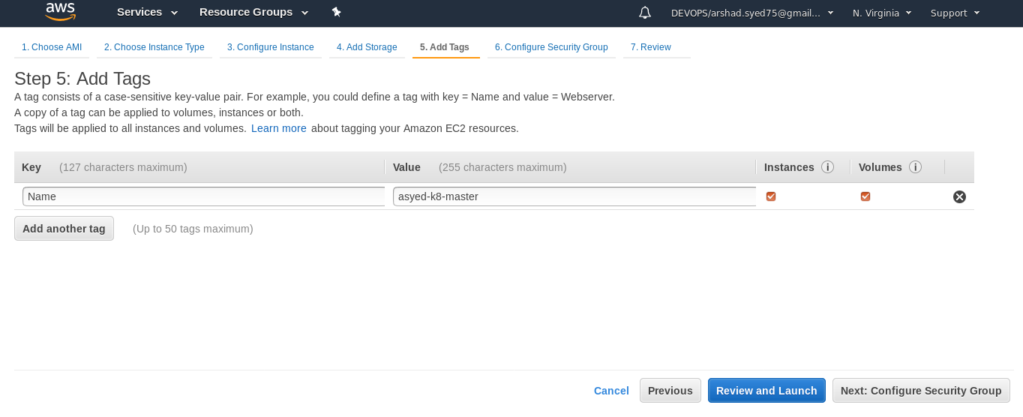

7.) On  **Configure Security Group**  Tab, Select **Assign Security Group** as **Select an existing security group** and select the security group with **Name** as **Golden-AMI** and then click on **Review and Launch**  button

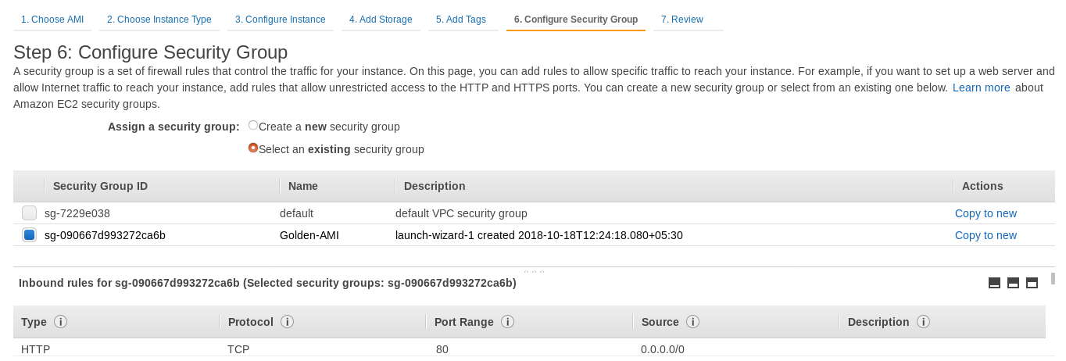

8.) On  **Review**  Tab, Review the instance details by scrolling the page and click on **Launch** button once all the details are verified.

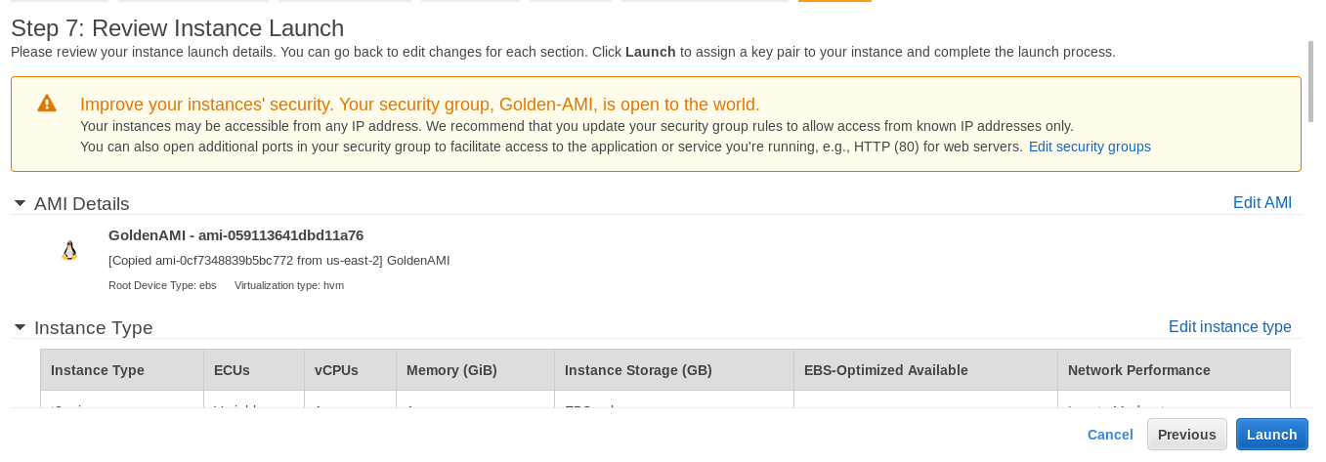

9.) Select **Choose an existing key pair** and select **GoldenAMI**, Select the **I acknowledge**  checkbox and click on **Launch Instances**

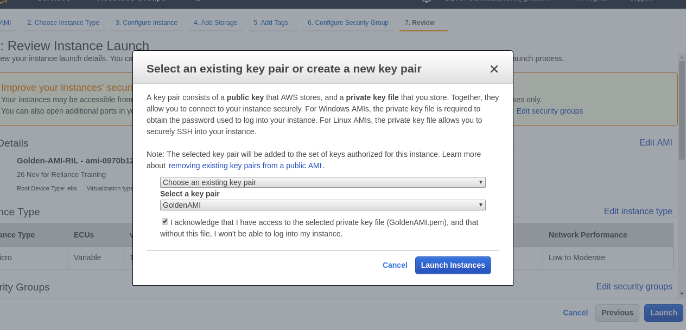

After completing the steps 1-9 **,** Navigate to **EC2 Dashboard > Instances** and View the details of the instance you just launched.

You can search for the instance under the search field with the **tag name** you associated during the launch configuration.

Once the **Instance State** start showing **running** and **Status Checks**  shows **2/2 checks passed**, Your instances will be launched completely . Select the instance row to view its details.You can find the Public IP address and other details of the instance in the **Description** Tab.

Note: the credentials for your instances are :--

Username : devops  
Password : Dev0p$!!/

**Run this command and replace xxx.xxx.xxx.xxx with public ip of your Workstation.**

**$ ssh devops@xxx.xxx.xxx.xxx**

Hit enter and enter the password **Dev0p$!!/**  when prompted